**Apache Web Server**

In this documentation we will install an Apache web server and serve html web pages using it.

Install Apache2

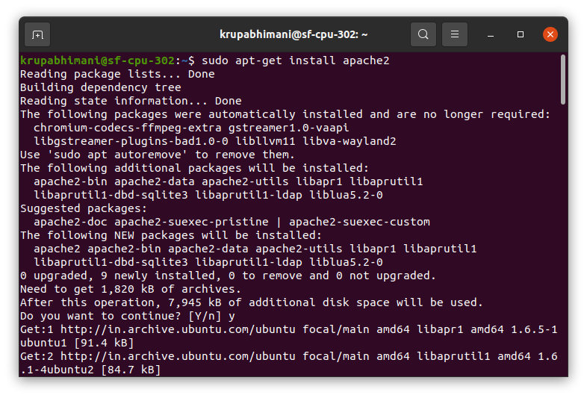

Now the server is installed , let’s start the server.

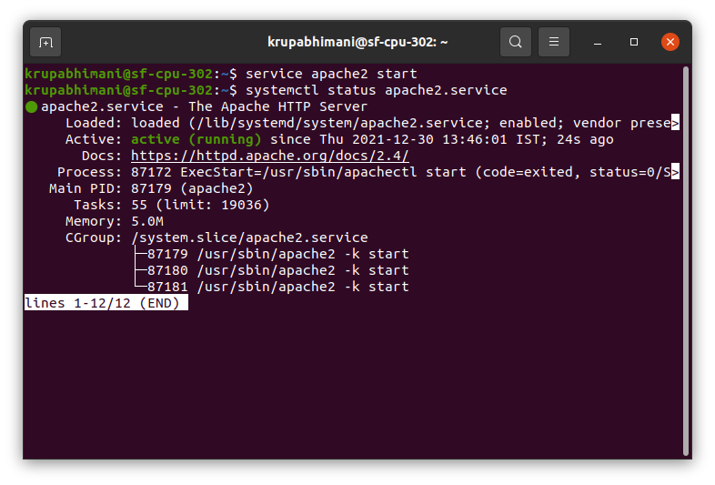

we can see the server is active and running.

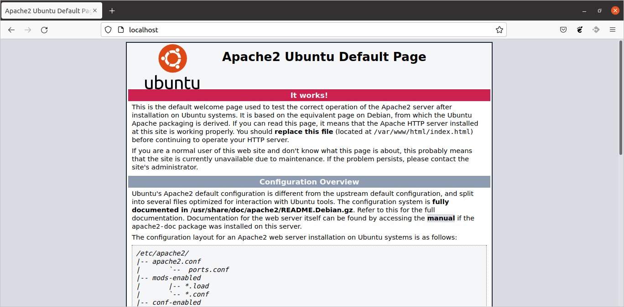

These are the files of apache2

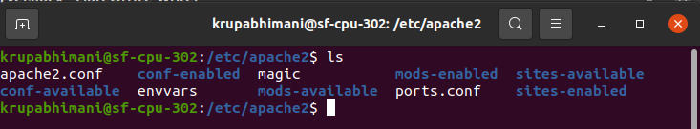

The main configuration file is apache2.conf

The default path for html page in Apache is /var/www

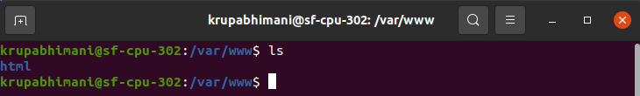

Now if we want to host our own website, we have created directories in www as shown by tree command.

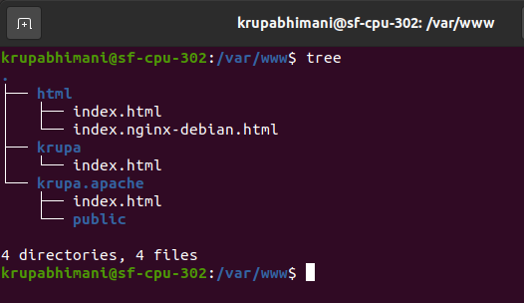

The html page that is running on our localhost is set to default in sites-available directory. If we want to host our own website we can create its directory in sites-available and do configuration in it.

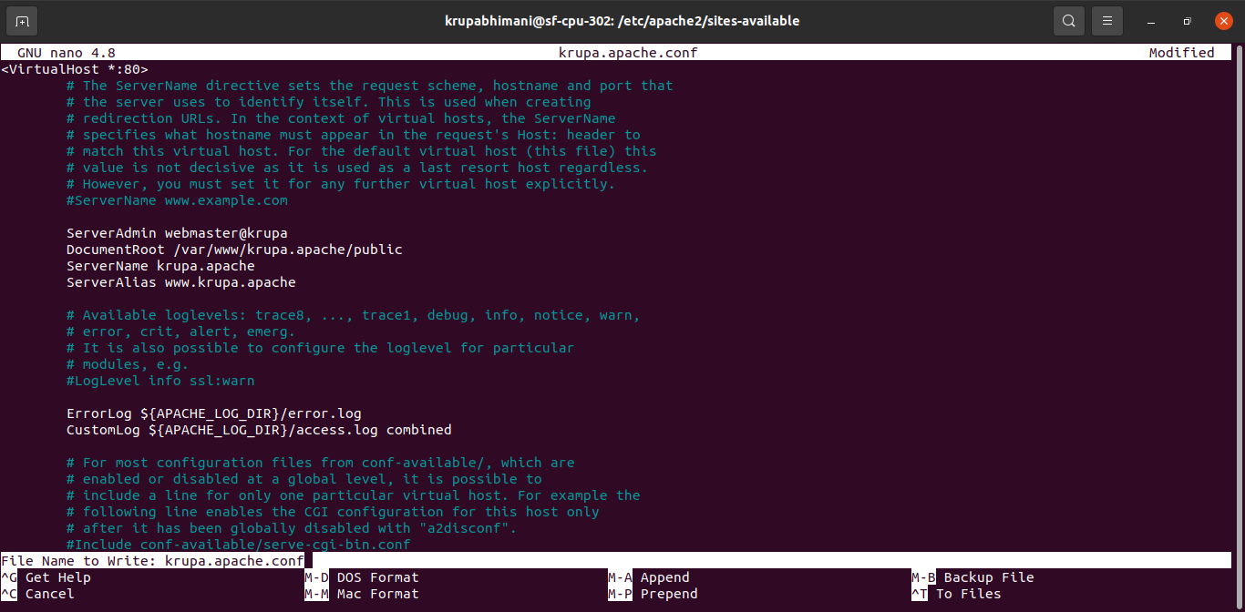

Create soft link of file in sites-enabled

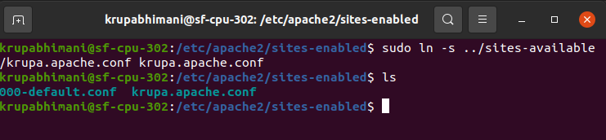

As we have configured everything we need to enable the configuration file

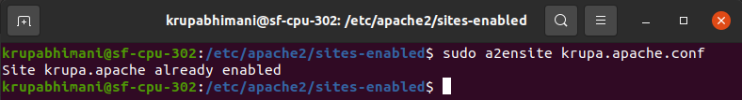

Restart the server

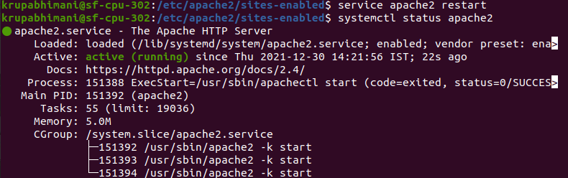

Now we will do changes in /etc/hosts file

